SPILL PREVENTION CONTROL AND COUNTERMEASURE PLAN

Indiana University
South Bend

INDIANA UNIVERSITY SOUTH BEND
ENVIRONMENTAL HEALTH & SAFETY

April 2010

INDIANA UNIVERSITY SOUTH BEND SPCC PLAN TABLE OF CONTENTS

SECTION PAGE

Section 1.0 - General Information 3
  - Abbreviations & Definitions 3
  - Introduction 3
  - Purpose and Scope 3
1.4 Plan Revision and Amendment 4
1.5 Plan Distribution 4
1.6 Certification of Substantial Harm Determination 4

Section 2.0 - Facility and Emergency Contact List 5

Section 3.0 - Site Information 5
3.1 Campus Description 5
3.2 Oil Storage Overview 5
3.3 Drainage Pathways and Distance to Navigable Waters 6

Section 4.0 - Spill History 7

Section 5.0 - Potential Spills and Containment Measures 7
5.1 Above Ground Tanks 7
5.2 Below Ground Tanks 7
  - Emergency Generators 7
  - Drum Storage 8
  - Transformers 8
  - Elevators 9
5.7 Grease Dumpsters 9
Section 6.0 - Spill Response and Emergency Procedures 9

Section 7.0 – Routine Containment Drainage 12

Section 8 – Oil Filling / Withdrawal / Overfill Protection 12

INDIANA UNIVERSITY SOUTHEAST SPCC PLAN TABLE OF CONTENTS (cont.)

SECTION PAGE

Section 9.0 - Inspections and Records 13

Section 10.0 Personnel Training 14

Section 11.0 Security 14

Section 12.0 – Waste Disposal 14

Section 13.0 – Annual Internal Auditing 14

APPENDICES
Appendix 1 Oil Transformer List 15
Appendix 2 Emergency Generator List 15
Appendix 3 Tank List 15
Appendix 4 Hydraulic Elevator List 15
Appendix 5 Certification of Substantial Harm Determination 16
Appendix 6 Emergency generator Checklists 17
Appendix 7 Hydraulic Elevator Checklists 18
Appendix 8 Hazardous Chemical Waste Contingency Plan 19
Appendix 9 Tank Inspection Standard 19
Appendix 10 Generator Tank Specifications 25
Appendix 11 Tank Inspection Form 26
Appendix 12 Emergency Generator Inspection Form 27
Appendix 13 Emergency Generator Photos 28
Appendix 14 Storage Tank Photos 33
Appendix 15 Topographic Map of IUSB 35
Appendix 16 Campus Map of IUSB 36
Appendix 17 Discharge Prevention Designee 37
Appendix 18 Discharge Prevention Briefing 38
Appendix 19 SPCC Audit Checklist 39

Section 1 - General Information

  - Abbreviations & Definitions

AST Aboveground Storage Tank
CFR Code of Federal Regulations
CWP Chilled Water Plant
DPD Discharge Prevention Designee
HAZWOPER Hazardous Waste Operations
IUSB EH&S Indiana University South Bend Environmental Health & Safety
IUSB Indiana University South Bend
OSHA Occupational Safety & Health Administration
PCB Polychlorinated Biphenyl
PPE Personal Protective Equipment
Primary Containment Tank Wall
Secondary Containment Tank Wall with 2nd wall or dike
Tertiary Containment Tank Wall with 2nd wall and dike
Sight Glass Tank Level Gauge
SPCC Spill Prevention and Control and Countermeasure
USEPA United States Protection Agency

1.2 Introduction

Indiana University South Bend (IUSB), utilizes several forms of energy to operate efficiently. In an effort to meet these energy demands, numerous oils are stored and used in various tanks, containers, and electrical equipment throughout the campus. These storage areas have been equipped with modern safety measures and are highly monitored to minimize any impacts to human health and the environment. A Spill Prevention Control and Countermeasures (SPCC) plan has been prepared for the South Bend Campus pursuant to the Environmental Protection Agency’s Oil Pollution Prevention Regulations (40 CFR Part 112). This SPCC Plan establishes preparedness, prevention, planning, spill response, and spill notification procedures as set forth in applicable state and federal regulations. This SPCC plan has been compiled by Indiana University South Bend Environmental Health and Safety (IUSB EH&S).

1.3 Purpose And Scope

The purpose of this SPCC Plan is to establish procedures and guidelines to prevent oil discharges on the IUSB campus. This plan specifically establishes proper procedures and equipment needed to
address any potential discharges of oils that could violate applicable water quality standards, cause a sheen upon or discoloration of the surface of navigable waters or adjoining shorelines, or cause sludge and emulsion to be deposited beneath the surface of any water body or upon any adjoining shorelines. The Plan has been prepared pursuant to regulations set forth in 40 CFR 112 which states that any facility having an oil storage capacity of 1,320 gallons aboveground or greater, and could reasonably be expected to discharge oil in harmful quantities into navigable waters of the United States must prepare and implement an SPCC Plan. Oil is defined in 40 CFR 112.2(a) as “oil of any kind or form, including, but not limited to petroleum, fuel oil, sludge oil, oil refuse and oil mixed with wastes other than dredged spoil.” The South Bend Campus stores these types of oil in sufficient amounts to necessitate the generation of an SPCC Plan.

1.4 Plan Revision and Amendment

As set forth in 40 CFR Part 112.5(a) and (b), this SPCC Plan shall be amended and re-certified whenever required by the Regional Administrator of the United States Environmental Protection Agency (USEPA), whenever applicable regulations are revised, or whenever there is a change in facility design, construction, operation, or maintenance which materially affects the facility’s potential for the discharge of oil into or upon the navigable waters of the United States or adjoining shorelines. In addition, the Plan shall be reviewed and evaluated at least once every five years. The current revision date of the plan is indicated on the cover page.

1.5 Plan Distribution

In order to promote campus awareness and to facilitate regular review, copies of the complete SPCC plan will be accessible at the following locations: Facilities Management and IUSB EH&S.

1.6 Certification of Substantial Harm Determination

As required under 40 CFR 112, a completed Certification of Substantial Harm Determination Form which demonstrates that IUSB does not meet the criteria for posing a risk of substantial harm to the environment is included as Appendix 5. Given the amounts and types of oil stored on the IUSB campus, the potential to cause substantial harm to the surrounding community does not exist.

Section 2 - Facility and Emergency Contact List

A list of emergency contacts that would be needed in the unlikely event of a major spill at the IUSB campus include the following:

Facilities Management
(574) 520-4386

University Police
(574) 520-4239

National Response Center
(800) 424-8802

Indiana Dept. of Environmental Management Spill Line
(888) 233-7745

South Bend City Fire Department
911

South Bend Waste Water Treatment
(574) 277-8515

Section 3 - General Site Information

3.1 Campus Description

The IUSB campus is located in South Bend Indiana, St. Joseph County. The campus is drained by a combination of enclosed storm sewer lines, and sheet flow that primarily empty into the St. Joseph River. The university occupies approximately 80 acres and owns 21 buildings. These buildings include lecture halls, laboratories, offices, student apartments and maintenance facilities (Appendix 16). A topographic map of the campus can be found in Appendix 15.

3.2 Oil Storage Overview

Oil and petroleum products are present throughout the IUSB campus in above ground storage tanks, below ground storage tank, emergency diesel fuel tanks, transformers, switches, pumps, compressors and other mechanical or electrical equipment. IUSB utilizes the following types of oil and petroleum products: gasoline, diesel fuel, transformer oil, lubricating oil, cooking oil, compressor fluid, motor oil and hydraulic fluid. The oils and petroleum products listed above are used in the following types of applications: emergency power generation; domestic uses; electrical transformers; vacuum pumps; hydraulic elevators and lifts; cooking equipment; and equipment maintenance activities.

Above & Below Ground Tanks

There are three large oil tanks on the IUSB campus. Two of these tanks are above ground and are not utilized for emergency generators. They both have a capacity of 250 gallons each. The total volume of these tanks is 500 gallons. These tanks are located outside of the Facilities Management maintenance area. The other tank is underground and is utilized for an emergency generator. This tank has a capacity of 10,000 gallons. A list of these tanks with their respective locations and capacities is provided in Appendix 3. All tanks are equipped with oil level gauges. Inspections and
tank integrity tests are also performed on a regular basis (see section 9.0).

Emergency Generators

Diesel fuel is also stored in the holding tanks of emergency generators located throughout campus. There are four electrical generators on campus with holding tanks. There is one generator on campus that has a below ground tank. The tank for that generator is listed in the above & below ground tank section. The total capacity of these tanks not including the below ground is 1,135 gallons. All generator tanks are equipped with fuel level gauges unless otherwise stated. A list of these generators along with their respective locations and capacities is provided in Appendix 2.

Transformers

There are currently 4 oil transformers located throughout the property. The estimated total volume of transformer oil on campus is approximately 861 gallons. There is one generator on campus that uses approximately 585 gallons of FR3transformer fluid. A complete list of transformers on campus is located in Appendix 1.

Elevators

There are currently 13 hydraulic elevators on the campus. The estimated total volume of hydraulic elevator oil on campus is approximately 3,481 gallons. A complete list of elevators and their oil capacities is located in Appendix 4.

3.3 Drainage Pathway and Distance to Navigable Waters

IUSB is located along the St. Joseph River in the watershed of Lake Michigan. A release on campus has the potential to reach the St. Joseph River depending on the location of the leak.

Section 4 - Spill History

There has been no recordable oil spills on the IUSB Campus.

Section 5 - Potential Spills and Containment Measures

Oil spills from containers on campus are unlikely, however, such events may be caused by ruptures, leaks, and overfills associated with these tanks. Each tank is listed below with a description of its volume, direction of flow in the event of a spill, secondary containment measures, and any spill response/cleanup equipment located in its vicinity.

5.1 Above Ground Tanks

Facilities Maintenance
Two tanks are located west of the Purdue Technology Building. These tanks include one 250 gallon diesel fuel tank and one 250 gallon gasoline tank. Each tank has a fuel gauge. Each tank has a concrete secondary containment tank. A major spill from one or both of these tanks would flow north and west to a dry well or grassy area. Spill response supplies are located in the Grounds Department shop in a large wheel garbage can.

5.2 Below Ground Tanks

There is one 10,000 gallon below ground fuel oil tank. The tank is located near the Education and Arts Building.

5.3 Emergency Generators

Each emergency generator tank is listed below with a description of its volume, direction of flow in the event of a spill, secondary containment, and any spill response/cleanup equipment located in its vicinity (Appendix 10 Generator Tank Specs.). Generator tanks are regularly inspected by Facilities Management personnel and inspection records are maintained by Facilities Management. Records of refilling processes are also kept in the Facilities Management office. See Section eight for additional filling procedures.

Northside Hall
This emergency generator tank holds 410 gallons of diesel fuel. The unit has a sub-base tank by ZBM. There is a drywell within 15 feet of the generator. Spill response equipment is located in the Grounds Department shop.

Administration Building
This emergency generator tank holds 125 gallons of diesel fuel. The unit has a sub-base tank. There is a catch basin within 30 feet. Spill response equipment is located in the Grounds Department shop.

Student Activities Building
This emergency generator tank holds 100 gallons of diesel fuel. It is located inside the Student Activities Center room 116A. There are no floor drains in the area. The unit uses a Klein Corporation closed top diked generator base tank. Spill response equipment is located in the Grounds Department shop.

Education & Arts
This emergency generator has a 500 gallon diesel fuel tank. The tank is located inside a steel container. Spill response equipment is located in the Grounds Department shop.

Education & Arts
This emergency generator is supplied by a 10,000 gallon below ground tank. It uses number 1 diesel fuel. It is located east of the Education and Arts building. Spill response equipment is located in the Grounds Department shop.

5.4 Drum Storage

Currently there are two 55 gallon drums in the Grounds Department shop. One contains new motor oil and one contains used motor oil. The drums are sitting on a secondary containment unit. Spill response equipment is located in the Grounds Department shop.

5.5 Transformers

As stipulated in 40 CFR 112.1 (b), transformers are not considered bulk oil storage containers. Rather, they are considered equipment which contains oil for operational purposes. Subsequently, this equipment does not require secondary containment. Appendix 1 contains a list of these transformers along with their location, capacity, and whether or not they are pole mounted or inside/outside a building. In the unlikely event of a leak, oil will be contained within the vault of these transformers.

5.6 Elevators

Five buildings on the IUSB campus have hydraulic freight and passenger elevators. Reservoirs associated with hydraulic elevators are not considered bulk oil storage containers because their contents are “in use”. Therefore, these hydraulic reservoirs are exempt from secondary containment requirements. Hydraulic elevator reservoirs are generally located in rooms separate from the elevator shaft (which usually resides in a pit). Oil reservoirs have the potential to leak into floor drains leading into sanitary sewers. Appendix 3 contains a list of elevators along with their location, capacity, and whether or not reservoir rooms contain floor drains.

5.7 Grease Dumpster

The food service facility in the Administration Building utilizes a grease dumpster to temporarily store waste oil associated with cooking processes. The container has the capacity to store approximately 100 gallons of grease and animal fat and is located in the loading dock of the building. The bin is emptied approximately twice a year by a local vendor. Any large spill would not be able to reach the storm sewers do to the slope of the loading dock area. A spill could reach the sanitary sewer.

Section 6 - Spill Response and Emergency Procedures

The goal of these emergency procedures is to eliminate the potential for oil spills to reach the St. Joseph River which runs through the IUSB campus. These procedures are intended to minimize human exposure and environmental impacts in the unlikely event a spill should occur. Responsibility for spill cleanup depends upon whether a spill is incidental or non-incidental. Incidental releases are limited in quantity, exposure potential, and toxicity and present minor safety or health hazards to employees in the immediate work area or those assigned to

the clean up. Responses to incidental releases of hazardous substances are to be performed when the substance can be absorbed, neutralized, or otherwise be safely controlled at the time of release by the employee in the immediate release area are not considered to be emergency response within the scope of this standard. Response to a release of this nature does not require full Hazardous Waste Operations & Emergency Response (HAZWOPER) training. Conversely, a non-incidental release is a release of a hazardous substance which poses a significant safety or health hazard to employees in the immediate vicinity or to the employee cleaning up the released hazardous substance. In addition, a non-incidental release has the potential to become an emergency within a short time frame. Employees that work with hazardous substances must be trained to protect themselves in handling non-incidental releases per the training requirements of the Hazard Communication standard (29 CFR 1910.1200) or the OSHA Lab Standard (29 CFR 1910.1450). A non-incidental released is defined by the situation and requires full HAZWOPER training. Non-incidental releases include the following situations:

The response comes from outside the immediate area of the release. (This includes in-plant personnel who are outside the immediately affected area but respond to the release.)

The release requires an evacuation of employees in the area.

The release poses, or has the potential to pose Immediately Dangerous to Life and Health (IDLH) conditions.

The release requires immediate attention because of imminent danger.

The release may cause high levels of exposure to toxic chemicals.

One is uncertain as to whether the employee in the work area can handle the severity of hazard considering the Personal Protective Equipment (PPE) and equipment provided.

The situation is unclear or data are lacking on important factors.

Incidental and non-incidental events must be determined on a case-by-case basis. However, the prime component is knowledge and understanding of the chemical, its hazards, and proper handling procedures. Other factors that play a role in this determination are the quantity released, ventilation considerations, confined space considerations, and personal protective equipment available. A

possibility also exists for a non-incidental release in an area that contains hazardous substances. Ultimately, the Discharge Prevention Designee (DPD) for each area is responsible for determining if a release is considered incidental or non-incidental (DPD form included in Appendix 17). The following flow chart may help DPDs with incidental, non-incidental and hazardous material spills:

IF YOU HAVE HAZARDOUS SUBSTANCES

TRAIN FOR INCIDENTAL RELEASE CLEAN-UP & HAZWOPER 1ST RESPONDER AWARENESS LEVEL FOR EVACUATION AND COMMUNICATION OF SPILL

HAZWOPER EMERGENCY RESPONSE RELEASE
INCIDENTAL RELEASE OCCURS

EVACUATE AS REQUIRED BY EMERGENCY ACTION PLAN & CONTACT EH&S EMERGENCY RESPONSE TEAM
CLEAN-UP SPILL AS PER HAZCOM STANDARD OR OSHA LAB STANDARD

Should an incidental spill occur, the following procedures will be followed immediately upon discovery:

- Remove all sources of ignition. If an ignition source cannot be removed, divert the spilled material away from the ignition source.

- Identify the released material and consult the appropriate Manufacturer’s Safety Data Sheet.

- Report the spill immediately to Environmental Health & Safety or University Police. If the spill presents an immediate danger to human life, evacuate the building and contact South Bend Fire Department.

- If the spill does not present an immediate danger to human life, contain spill with absorbent material, spill pads, spill socks, or other containment equipment available.

- If the amount of spilled material is minimal and incidental, absorb and containerize and contact Environmental Health & Safety or University Police regarding proper disposal methods.

- If the amount of spilled material is large or non-incidental, contain it as much as possible, contact Environmental Health & Safety or University Police, and monitor the area until trained response personnel arrive. Should any spill be deemed non-incidental, it must be considered a ‘hazardous waste release’ which will then require an official response by the South Bend Fire Department only.

- IUSB utilizes a Hazardous Chemical Waste Contingency Plan which has been included in Appendix 8.

- The SPCC Facility Response Coordinator (IUSB EH&S Manager) will determine if a reportable spill has occurred. If so, the appropriate notifications will be made to government agencies followed by a written report. Documentation of spills covered by this plan will be maintained by IUSB EH&S. State regulations require facilities that spill more than 1,000 gallons of oil (or simply discover a sheen on a surface water body associated with a spill) to report the incident.

- This plan will be reviewed after each covered spill to evaluate its effectiveness in the spill response effort. If deficiencies are found the plan will be revised.

- All cleanups in confined spaces must follow standard procedures outlined in the IUSB Confined Space Program Manual.

Section 7 – Routine Containment Drainage

Exposed containment measures such as dikes can collect rainwater and are routinely drained. IUSB personnel are responsible for inspecting collected water for oil sheens. If no sheen is present, rainwater is drained into sanitary sewers and storm drains. If a sheen is found, cleanup measures such as booms and absorbents are used to remove free product and are then disposed of properly. Records of an oil sheen clean-up are recorded and additional tank inspections are made.

Section 8 – Oil Filling / Withdrawal / Overfill Protection

All tanks have high level alarms, shut offs, or (at a minimum) gauges to be monitored during filling. Regardless, the following general procedures will be followed while filling ASTs and Emergency Generator tanks:

- No smoking is allowed while unloading combustible or flammable materials.

- Truck engines and emergency generators will be turned off during the unloading process unless used to operate a fuel pump.

- The driver will remain with the vehicle at all times during unloading.

- The entire unloading event will be monitored by truck drivers and IUSB employees to ensure maximum safety. Both parties will have unobstructed views of the truck and tank throughout the unloading process. If refueling must take place from a remote location, one party will inspect the tank while the other party unloads. The parties must also use radio communication systems during the refueling process.

- Unloading will be preformed only in areas designated for this purpose.

- Unloading shall not begin until tank instruments and/or a visual inspection of fill ports indicate enough volume is available to accept a transfer. Automatic refill instrument shall be set to 85-90 percent.

- Upon the completion of a transfer, all truck valves will be closed and the unloading hose drained back to the storage tank before disconnection by the driver.

- Procedures for addressing spills will be followed by all IUSB personnel in the unlikely event of a spill. Any spills or leaks not contained with local equipment will be immediately reported to Environmental Health & Safety or University Police.

Section 9 - Inspections and Records

Monthly inspections are made of the storage tanks by individuals in accordance with the Steel Tank Association’s Standard SP001-00 included as Appendix 9. These inspections are documented and kept on file at the Facilities Management office along with any manufacturing information and general tank specifications. The inspections consist of a visual check for signs of leaking and deterioration of the tank, containment area, and associated piping. The fuel gauge requires an annual inspection. The fuel gauge on each tank should be removed and checked for an accurate fuel level reading. Inspections of the emergency generators are performed by Facilities Management personnel as well as outside contractors. Transformers are maintained by AEP. Hydraulic elevators are inspected by an outside contractor. Leaks from elevators are quickly addressed due to equipment failure. Two forms are included in the plan for use by IUSB personnel: Appendix 11 Tank Inspection Form and Appendix 12 Emergency Generator Inspection Form

Section 10.0 - Personnel Training

Workers involved with oil stores on campus have been trained in the safe operation and maintenance of oil-related equipment to eliminate the potential for spills. This training includes familiarization with Material Safety Data Sheets, spill response procedures, inspection methods, oil filling and withdrawal procedures, routine rain water drainage from dikes, and other requirements of this plan. Discharge prevention briefings are performed and documented by the DPD assigned to each department. These records are submitted to EH&S for review on an annual basis. All new personnel will receive training within a reasonable time frame and records of training sessions will be maintained for five years. See Appendix 18 for Discharge Prevention Briefing form.

Section 11 - Security

Indiana University South Bend maintains its own police department and regular security patrols are made throughout the campus in an effort to protect vital resources. The campus is sufficiently lit to allow for the discovery of any spills during evening hours and to discourage vandalism. The department has the emergency contact list so that any spills after office hours can be addressed promptly. IUSB’s Facilities Management personnel perform routine inspections of all oil containment areas.
Section 12.0 – Waste Disposal

Once spills have been contained, absorbed or segregated from a vulnerable area, they must be disposed of properly. A disposal determination shall be made by the Environmental Health & Safety Department. Any free product in a liquid state shall be containerized in waste cans or 55-gallon drums. Arrangements shall then be made with a hazardous waste contractor for proper pickup and disposal. Any solid materials associated with an oil or fuel spill (except gasoline) such as absorbent pads, pigs, and clay chips are generally not considered hazardous and can be disposed of in typical waste receptacles. However, solid materials used in the cleanup should also be contained and arrangements made with a hazardous waste contractor for proper pickup and disposal.

Section 13.0 – Annual Internal Auditing

Annual internal auditing of all requirements in this plan shall be conducted by EH&S at least every five years to ensure IUSB is in compliance with the SPCC Plan. Findings from these audits will then be used to improve the plan and increase the campus’ ability to eliminate the potential for spills to reach surrounding water bodies. The SPCC Audit Checklist is included as Appendix 1.

Appendix 1 Oil Transformer List
Location Gallons of Oil
Northside Hall 585 (FR3)
Riverside Hall 81
Administration Building 374
Schurz Library 230
Purdue Technology 175

Appendix 2
Emergency Generator List (photos in Appendix 15)
Building Oil type Gallons
Northside Hall Diesel 410
Education & Arts Diesel 500
Administration Building Diesel 125
Student Activities Center Diesel 100

Appendix 3
Tank List (photos in Appendix 16)
Building Above/Below Ground Oil type Gallons
Purdue Technology Above Diesel 250
Purdue Technology Above Gasoline 250
Education & Arts Below #1 Fuel Oil 10,000

Appendix 4
Hydraulic Elevator List
Building Gal.
Northside Hall (32217) 142
Parking Garage (47677) 276
Parking Garage (47673) 284
Library (44910) 260
Library (44909) 260
Library (44911) 221
Purdue Technology (47194) 225
Wiekamp Hall (48814) 503
Wiekamp Hall (48812) 258
Wiekamp Hall (48813) 515
Student Activities Center (100592) 119
Student Activities Center (100591) 200
Student Activities Center (100593) 218

Appendix 5
Certification of Substantial Harm Determination

Does the facility have a maximum storage capacity greater than or equal to 42,000 gallons and do the operations include over water transfers of oil to or from vessels?

No

Does the facility have a maximum storage capacity greater than or equal to one million (1,000,000) gallons and is the facility without secondary containment for each aboveground storage area sufficiently large to contain the capacity of the largest aboveground storage tank within the storage area?

No

Does the facility have a maximum storage capacity greater than or equal to one million (1,000,000) gallons and is the facility located at a distance such that a discharge from the facility could cause injury to an environmentally sensitive area as defined in Appendix A of 40 CFR 112?

No

Does the facility have a maximum storage capacity greater than or equal to one million (1,000,000) gallons and is the facility located at a distance such that a discharge from the facility would shut down a public drinking water intake?

No

Does the facility have a maximum storage capacity greater than or equal to one million (1,000,000) gallons and within the past 5 years, has the facility experienced a reportable spill in any amount greater than or equal to 10,000 gallons?

No

Appendix 6
Emergency Generator Checklists

SPCC Checklist for Generator Tanks Date:

Location of tank and generator(Building name and room #):

Main Tank Size and containment type and amount:

Day tank size and location if different from above including containment type and amount:

Spill equipment available? If so describe what and where it is located:

Tank contents labeled as diesel fuel and No Smoking?*

Fire Extinguisher available/location?*

Spill History:

Possible failure scenarios:

Fate of spilled oil included affected waterway:

Refill/withdrawal procedures:

Are routine inspections performed?

Are personnel trained in spill response, refill/withdrawal and inspections of this tank?

Additional Comments:

Appendix 7
Hydraulic Elevator Checklists

SPCC Checklist for Hydraulic Elevator Tanks Date:

Location of tank(s) and elevator (Building name and room #):

Tank(s) Size and containment type and amount:

Elevator location if different from above including containment type and amount:

Spill equipment available? If so describe what and where it is located:

Spill History:

Possible failure scenarios:

Fate of spilled oil included affected waterway:

Refill/withdrawal procedures:

Are routine inspections performed?

Are personnel trained in spill response, refill/withdrawal and inspections of this tank?

Additional Comments:

Appendix 8
Hazardous Chemical Waste Contingency Plan
IU South Bend Police Department will contact the South Bend Fire Department for any hazardous chemical spill that constitutes as a major spill.

Appendix 9 Tank Inspection Standard
STEEL TANK INSTITUTE
STANDARD FOR INSPECTION
OF IN-SERVICE SHOP FABRICATED
ABOVEGROUND TANKS
FOR STORAGE OF
COMBUSTIBLE AND FLAMMABLE LIQUIDS
SP001-00
Steel Tank Institute
570 Oakwood Road
Lake Zurich, IL 60047
847/438-8265
Fax: 847/438/8766
www.steeltank.com
COPYRIGHT © 2000 by Steel Tank InstituteAST Inspection Standard September 2000 1
1.0 GENERAL
1.1 This standard covers the inspection of shop fabricated steel tanks built to a
nationally recognized standard for aboveground storage tanks that are
intended for the aboveground storage of noncorrosive, stable, flammable, and
combustible liquids having a specific gravity not exceeding that of water.
1.2 The purpose of the inspection shall be to determine the condition of the tank
and whether it is leaking.
1.3 The scope is limited to the tank foundation, supports, inner and outer walls,
piping to the face of the first flange, the first threaded joint, or the first welded-end
connections, including normal and emergency vents. Other accessories
are not included.
1.4 This Standard is intended for use by organizations and/or individuals who are
knowledgeable and experienced in aboveground tank inspection. Applicable
federal, state and local laws, regulations and ordinances concerning tank
inspection shall also be consulted.
1.5 Consult the tank manufacturer prior to making any alterations or repairs to a
tank.
2.0 DEFINITIONS
2.1 Aboveground storage tank–a tank which is wholly aboveground, i.e. not
partially buried. The tank may be resting on the ground, or set on supports,
such as saddles, skids, legs, etc. It may be installed in an underground vault.
2.2 Primary tank–for tanks which are single-wall, it is the containment tank. For
double-wall tanks, it is the inner tank.
2.3 Secondary tank–for tanks which are double-wall, it is the outer tank.
2.4 Double wall tank–an aboveground storage tank with a tank contained within a
containment tank. This will form an interstitial (annular) space between the
two tanks which is capable of being monitored for leakage into the space from
either the interior or exterior walls.
2.5 Single-wall tank–an aboveground storage tank with only one wall or shell.
2.6 Secondary containment dike–a structure which is intended to contain product
resulting from a spill, leak, or rupture of the tank. The tank may be either
single wall or AST Inspection Standard September 2000 2
2.7 Manway–an opening in the tank designed to allow personnel entry.
2.8 Tank in contact with the ground–a tank which does not allow for the visual
inspection of the exterior of the bottom of the tank. This includes a tank in
contact with soil or in contact with a concrete foundation. It also includes a
tank which is supported above the ground, but the conditions do not allow for
a visual inspection of the exterior of the bottom of the tank.
2.9 Tank supports–structures designed to elevate a tank above the ground.
These include saddles, skids, beams, legs, and similar structures.
2.10 Corrosion–the degradation of metals due to chemical reactions with their
environment. In steel, this is commonly known as “rust.”
2.11 Pitting–small but sharp cavities on a surface due to corrosion.
2.12 Interstice–in double wall tanks, the space between the primary tank and
secondary tank. This space may be monitored by a vacuum or leak detection
equipment.
3.0 TANK INSPECTOR QUALIFICATIONS
3.1 Periodic tank inspections are to be performed by the tank owner or his
designate.
3.2 Qualified tank inspectors are to perform the certified tank inspections.
Qualified tank inspectors are those who are certified by one or more of the
following sources:
3.2.1 American Petroleum Institute Certified Aboveground Storage Tank
Inspector Contact: American Petroleum Institute, Aboveground
Storage Tank Inspector Certification Program, 1220 L Street NW,
Washington, DC 20005
3.2.2 STI trained and certified tank inspectors who have received their
training by Steel Tank Institute (STI) Contact: STI, 570 Oakwood
Rd., Lake Zurich, IL 60047. These inspectors shall be trained in
accordance with the STI Standard “AST Inspector Qualification
Procedure.”double wall. The dike AST Inspection Standard September 2000 3
4.0 PERIODIC INSPECTION (PERFORMED BY TANK OWNER OR HIS
DESIGNATE)
4.1 The following situations are considered Critical Situations. These REQUIRE
IMMEDIATE ATTENTION. Inspect the tank for serviceability and make
corrections as required prior to returning it to service.
4.1.1 Take a tank out of service immediately (within 24 hours) if a leak is
found in the tank at any time. Repair or replace the tank. Consult
the tank manufacturer prior to making any alterations or repairs to a
tank.
4.1.2 If the tank has been exposed to a fire or other means which could
cause possible damage, inspect the tank for serviceability and
leaks prior to being put into service. Follow the inspection criteria
described in paragraph 5.0 below. Make corrections and/or repairs
as required. Consult the tank manufacturer prior to making any
alterations or repairs to a tank.
4.1.3 Check for proper drainage during or after a major storm in
accordance with paragraph 4.6 below.
4.2 Monthly, check the primary tank for the presence of water at the lowest
possible point(s) inside the tank. In addition, check the secondary tank or
secondary containment if the aboveground tank is so equipped. Remove any
water found. Bacteria in the water can cause corrosion and plug filters. If
water is found in a tank, check for the presence of corrosion inducing bacteria
using a microbe detection kit. If bacteria are present, treat with a suitable
bactericide. See the US Department of Energy BNL 48406, a report which
provides additional information. Remove a tank from service that has a
known leak in either the primary or secondary tank or secondary containment.
4.3 Monthly, inspect the interstice of a double wall tank for the presence of fuel. If
tank is so equipped, check the leak detection system and replace or correct
as necessary. Check groundwater wells if the tank is so equipped. Remove a
tank from service that has a known leak in either the primary or secondary
tank or secondary containment.
4.4 Monthly, inspect all pipe connections to the tank for evidence of leakage.
Replace the gaskets in flanged connections, as necessary, with ones
compatible with the stored fluid and rated to cover the temperature extremes
of the tank environment. Tighten threaded connections if necessary.
4.5 Quarterly, perform a walk-around inspection to identify and repair areas of
damage to the tank or its coating. Clean the exterior if necessary. Promptly
repair any deficiencies that are found. It is important that the tank exterior be
inspected periodically to ensure that the integrity of the coating is maintained.may be either open or closed at the top. AST Inspection Standard September 2000 4
The frequency of periodic recoating (repainting) will be based upon
environmental factors in the geographic area where the tank is located. Give
special consideration when recoating to the selection of the coating, surface
preparation and coating application. Select a coating of industrial quality that
is compatible with the existing coating or else remove the existing coating
prior to recoating.
4.6 Quarterly, inspect and clean normal operating vents and emergency vents on
the primary tank (and secondary tank and secondary containment tank, if
applicable) and spill containers. Refer to Appendix for instructions.
4.7 Once a year, perform a walk-around inspection checking for proper drainage
around the tank area. Proper site maintenance is vital to ensure drainage of
surface water. Check for ground settling and puddling of water near the tank.
Correct as necessary. If ground conditions change or settlement occur,
correct the situation by providing drainage or regrading to prevent standing
water from being in contact with the steel tank and its supports.
4.8 Once a year, check o-ring/gasket of emergency vents for damage or
deterioration.
4.9 Once a year, inspect the tank supports to determine if there is damage or
deterioration of the supports. Inspect the supports for signs of damage from
vehicles, misuse, and corrosion. Damage may require replacement of the
supports. Contact the tank manufacturer for their recommendation. If
deterioration has occurred, more frequent inspections may be required. (See
paragraph 6.0 for further details.) Periodic recoating of the supports may be
necessary.
4.10 Once a year, inspect the tank foundation for signs of settlement, cracking,
pitting, and spalling. Contact a qualified contractor for repair of concrete
foundations. Observe the condition of the anchor bolts to determine if there
has been distortion of the bolts or significant cracking around the bolts.
Replace the bolts if they have deteriorated.
4.11 If a cathodic protection system has been installed on the tank to prevent
corrosion of the bottom of the tank, perform periodic readings of the system to
be sure that the protection remains adequate in accordance with local, state,
and federal guidelines. This procedure shall be performed by a qualified
cathodic protection tester. The criteria for protection shall be as defined by
NACE RP-0285, “Corrosion Control of Underground Storage Tank Systems
by Cathodic Protection.” AST Inspection Standard September 2000 5
5.0 CERTIFIED INSPECTION (PERFORMED BY QUALIFIED TANK
INSPECTOR, AS DEFINED IN PARAGRAPH 3.2)
5.1 Every 10 years, or as determined in paragraph 6.0, inspect all tanks as
follows:
5.1.1 Perform all monthly, quarterly, and yearly inspections listed in
paragraphs 4.2 through 4.9 above.
5.1.2 Pressure test the tank for tightness. Consult tank manufacturer
installation instructions or the Steel Tank Institute Recommended
Practice R912-00, “Installation Instructions for Shop Fabricated
Stationary Aboveground Storage Tanks for Flammable,
Combustible Liquids. Air should not be used for a pressure test and
an inert gas should be used instead. The introduction of a gas
containing oxygen (such as air) to a tank which has previously held
a petroleum product can pose a explosion hazard.

5.2 Every 10 years, or as determined in paragraph 6.0, inspect single wall
horizontal, rectangular, or vertical tanks which are not in contact with the
ground (as defined in paragraph 2.8 above) in one of the following ways:
5.2.1 If the tank is equipped with a manway, either conduct ultrasonic
testing as described in paragraph 5.5 below, or visually examine
the interior of the tank as described in paragraph 5.6 below.
5.2.2 If the tank is not equipped with a manway, another inspection
method is necessary. Either use “Method C–Invasive Permanently
Recorded Visual Inspection and Evaluation Including External
Corrosion Assessment” described in ASTM G 158, “Standard
Guide for Three Methods of Assessing Buried Steel Tanks” or use
ultrasonic testing to determine the wall thickness of the tank as
described in 5.5 below.
5.3 Every 10 years, or as determined in paragraph 6.0, inspect single wall
(horizontal, rectangular, or vertical) tanks which are in contact with the ground
(as defined in paragraph 2.8 above) in one of the following ways:
5.3.1 Inspect tanks which are constructed with a double bottom and
include a vacuum on the interstice the same as double wall tanks
(as described in paragraph 5.4 below).
5.3.2 If a cathodic protection system has been installed on the tank
bottom to protect the exterior of the tank bottom the following steps
shall be taken:
5.3.2.1 Examine the periodic readings which have been taken to
be sure that the cathodic protection remains adequate in
accordance with local, state, and federal guidelines.
These periodic readings shall have been performed by a
qualified cathodic protection tester. The criteria forAST Inspection Standard September 2000 6
protection shall be as defined by NACE RP-0285,
“Corrosion Control of Underground Storage Tank
Systems by Cathodic Protection.”
5.3.2.2 Inspect the interior of the tank per paragraph 5.1.1 or
5.1.2, as applicable.
5.3.3 If a cathodic protection system has not been installed on the tank
bottom to protect the exterior of the tank bottom, determine the
thickness of bottom using one of the following methods:
5.3.3.1 If the tank is equipped with a manway, use ultrasonic
testing as described in paragraph 5.5 below.
5.3.3.2 If the tank is not equipped with a manway, take the tank
out of service and inspect the bottom. This will require
disconnecting associated piping and excavating or
moving the tank so that the thickness of the tank bottom
can be determined. Determine the remaining thickness
per paragraph 5.5 below. Inspect the interior of the tank
per paragraph 5.2.2 above.
5.4 Every 10 years, inspect double wall (horizontal, rectangular, or vertical) tanks,
which are either in contact or not in contact with the ground as follows:
5.4.1 Verify that the leak detector equipment is operating if the tank is so
equipped.
5.4.2 Check for water and fuel in the interstice.
5.5 Described below is the ultrasonic testing procedure. Determine the minimum
remaining wall thickness.
5.5.1 This testing shall be performed by a qualified person in accordance with the American Society for Nondestructive Testing, ANSI/ASNT CP-189 “ASNT Standard for Qualification and Certification of Nondestructive Testing Personnel.”
5.5.2 Ultrasonic testing equipment that is capable of scanning the tank, rather than measuring only individual points, is the preferred method of performing the testing.
5.5.3 If using ultrasonic testing equipment which is capable of scanning the tank is not practical, use equipment which tests individual points. In this case, perform wall thickness measurements of the portion of the tank described in paragraph 5.5.4 below on at least 15 points in each 12 inch square area.
5.5.4 Test the bottom 60 E of a horizontal cylindrical tank. Test the bottom and the lower 12 inches of the sides of a vertical cylindrical or a rectangular tank.
5.5.5 Consider the construction of lap joints in all inspections. Lap joints which allow water to accumulate may lead to accelerated corrosion and therefore require special attention during inspections. AST Inspection Standard September 2000 7
5.6 Described below is the visual testing procedure. If corrosion and pitting is found, determine the minimum remaining wall thickness.
5.6.1 Do not enter a tank until you have determined that a breathable, non-explosive atmosphere exists within the tank. Follow OSHA requirements for confined space entry and see NFPA 326, “Standard for the Safeguarding of Tanks and Containers for Entry, Cleaning or Repair.”
5.6.2 Use sufficient light to illuminate the interior of the tank.
5.6.3 Check for the presence of water, excessive corrosion, and other forms of deterioration.
5.6.3.1 Measure the extent and depth of any pitting found.
5.6.3.2 Inspect all welds.
5.6.3.3 Determine the extent of general corrosion.
5.6.4 Consider the construction of lap joints in all inspections. Lap joints which allow water to accumulate may lead to accelerated corrosion and therefore require special attention during inspections.
6.0 CERTIFIED TANK INSPECTION CRITERIA
6.1 After the minimum remaining wall thickness is determined in paragraph 5, apply the following criteria to determine if the tank may remain in service:
6.1.1 If less than 5% of any 12 inch by 12 inch square area of the tank has a remaining wall thickness less than or equal to 50% of the original thickness, remove the tank from service and contact a qualified tank manufacturer to have these sections repaired. Bring the thickness of these areas back to the original design thickness. Have the qualified inspector re-inspect the tank after the repairs have been made. Identify and correct the cause of corrosion. Re-inspect the tank in 5 years, or less as recommended by the qualified tank inspector.
6.1.2 If more than 5% of any 12 inch by 12 inch square area of the tank has a remaining wall thickness less than or equal to 50% of the original thickness, remove the tank from service and contact a qualified tank manufacturer to have these sections repaired. These sections must be repaired by cutting out these sections and replacing them with new steel of the original design thickness or else by welding new steel of the original design thickness over the damaged areas. These repairs must be made from the side that is corroded. Have the qualified inspector re-inspect the tank after the repairs have been made. Identify and correct the cause of corrosion. Re-inspect the tank in 5 years, or less as recommended by the qualified tank inspector.
6.1.3 If the remaining wall thickness is more than or equal to 50% but less than 75% of the original thickness, identify and correct the cause of corrosion. Re-inspect the tank in 5 years, or less asAST Inspection Standard September 2000 8
recommended by the qualified tank inspector.
6.1.4 If the remaining wall thickness is greater than or equal to 75% of the original thickness, re-inspect the tank in 10 years, or less as recommended by the qualified tank inspector.
6.2 Suggested methods of determining the original thickness are as follows:
6.2.1 Review the original tank documentation, such as drawings and packing lists.
6.2.2 Consult the tank manufacturer.
6.2.3 Examine the tank labels for evidence of a widely accepted tank standard, such as Underwriters Laboratories Standard UL 142, etc. Consult the referenced standard to determine the minimum design wall thickness.
6.2.4 Measure the tank thickness of several areas of the tank which have no visible corrosion or pitting. The smallest of these measurements will result in a minimum design thickness which can be used.
7.0 RECORD KEEPING
7.1 Keep records of Periodic Inspections (performed by tank owner or his designate) for the previous year and the current year or as required by local, state, and federal guidelines. Refer to the section of this document called, “Checklists” for suggested records format.
7.1.1 Keep results of the last two inspections of a cathodic protection system, if applicable.
7.2 Keep records of any “Critical Situation”, as defined in paragraph 4.1 above, for the entire life of the tank.
7.3 Keep records of the Certified Inspection (performed by Qualified Tank Inspector, as defined in paragraph 3.2) for the entire life of the tank. Refer to the section of this document called, “Checklists” for sugAST Inspection Standard September 2000 9
REFERENCES
American Petroleum Institute, API Standard 653, Tank Inspection, Repair, Alteration, and Reconstruction, 1998.
American Society for Nondestructive Testing, ANSI/ASNT CP-189, ASNT Standard for Qualification and Certification of Nondestructive Testing Personnel, 1995.
American Society for Testing and Materials, ASTM G 158, Standard Guide for Three Methods of Assessing Buried Steel Tanks, 1998.
National Fire Protection Association, NFPA 326, Standard for the Safeguarding of Tanks and Containers for Entry, Cleaning, or Repair, 1999
NACE International, NACE RP-0285, Corrosion Control of Underground Storage Tank Systems by Cathodic Protection, 1995.
Steel Tank Institute, STI-R893, Recommended Practice For External Corrosion Protection of Shop Fabricated Aboveground Tank Floors, 1989.
Steel Tank Institute, STI-R912, Installation Instructions for Shop Fabricated Stationary Aboveground Storage Tanks for Flammable, Combustible Liquids, 2000.
Underwriters Laboratories Inc., UL 142, Steel Aboveground Tanks for Flammable and Combustible Liquids, 1998.
United States Environmental Protection Agency, EPA 510-K-95-002, Musts for USTs–A Summary of Federal Regulations For Underground Storage Tank Systems, 1995.gested records format. AST Inspection Standard September 2000 10
APPENDIX
The diagram below is included to assist in the identification of the accessories of
Aboveground Storage Tank which are to be inspected per paragraph 4. Any specific
individual tank may include one or all of these accessories.
The purpose of these accessories is as follows:
1. Spill Container–This tank accessory is designed to catch any spills during
tank filling operations. It typically has a lockable, hinged lid and allows any
spilled fluid to drain into the tank.
2. Tank Vent (and Riser)–This tank accessory allows air to enter the tank when
fluid is being withdrawn and also exhausts air when the tank is being filled.
This prevents damage to the tank due to too much pressure. The vent is
typically installed on a pipe which is 12 feet above the ground.
3. Emergency Vent (for Primary and Secondary Tank)–These tank accessories
prevent damage to the tank by allowing excess pressure to be vented. They
are designed to relieve excess pressure in the event of an emergency, such
as a fire.
4. Monitor Pipe for Leak Detection–This pipe is installed in the air space
(interstice) between the primary tank and secondary tank of a double wall
tank. It is typically used with leak detection equipment to detect a leak in
either the primary or secondary tank.
5. Tank Supports–These AST Inspection Standard September 2000 11
MAINTENANCE INSTRUCTION FOR SPILL CONTAINER
1. Quarterly, clean and inspect inside and outside of container.
2. Quarterly, check condition of hinge, locking mechanism, and drain apparatus.
Replace if necessary.
MAINTENANCE INSTRUCTION FOR TANK VENT
1. Visual check daily for any obstruction on top of vents that would prevent
operation.
2. Quarterly check the operation of vent by checking for any internal obstruction
of the vent and screen if applicable. Clean as needed.
MAINTENANCE INSTRUCTION FOR EMERGENCY VENTS
1. Visual check daily for any obstruction on top of emergency vents that would
prevent its operation.
2. Quarterly check the operation of the emergency vents by lifting the top and
check for any internal obstruction of the emergency vent and screen if
applicable.
3. Annually check o-ring/gasket for damage or deterioration.
Diagram of Emergency Vent structures are used to elevate the tank off the ground.
AST Inspection Standard September 2000 12

Appendix 10
Generator Tank Specifications (contact IUSB Facilities Management)

Appendix 11 Tank Inspection Form
SPCC MONTHLY PHYSICAL INSPECTIONS
TANK
Date: | GASOLINE | DIESEL | Comment
Inspect valves & piping
Inspect metal surface of tank & support
Check for leaks at base of tank
Check containment for leaks, cracks, etc…
Containment cleaned & pumped (as needed basis)
Tank secured / locked
Are tanks labeled correctly?
Is spill equipment present/accessible?
Check that tank vents are clear of obstruction & operational
Spill cleaned up
SOP accessible for drainage of containment?
SOP accessible for proper filling & withdrawal procedures?
Comments:
Inspected By:
SPCC ANNUAL REQUIREMENTS
Test fuel gauge (once per year)
Conduct employee briefing (at least once per year)

Appendix 12 Emergency Generator Inspection Form

SPCC MONTHLY PHYSICAL INSPECTIONS
Emergency Generators
Location of Generator:
Date: | Comments
Inspect valves & piping
Inspect metal surface of tank & support
Check for leaks at base of tank
Check containment for leaks, cracks, etc.
Containment cleaned & pumped (as needed basis)
Tank secured/locked
Are tanks labeled correctly?
Is spill equipment present/accessible?
Check that tank vents are clear of obstruction & operational
Spill cleaned up
SOP accessible for drainage of containment?
SOP accessible for proper filling & withdrawal procedures?
Comments:
Inspected by:
SPCC Annual Requirements
Test fuel gauge (once per year)
Employee briefing (once per year)

Appendix 13 Emergency Generator Photos

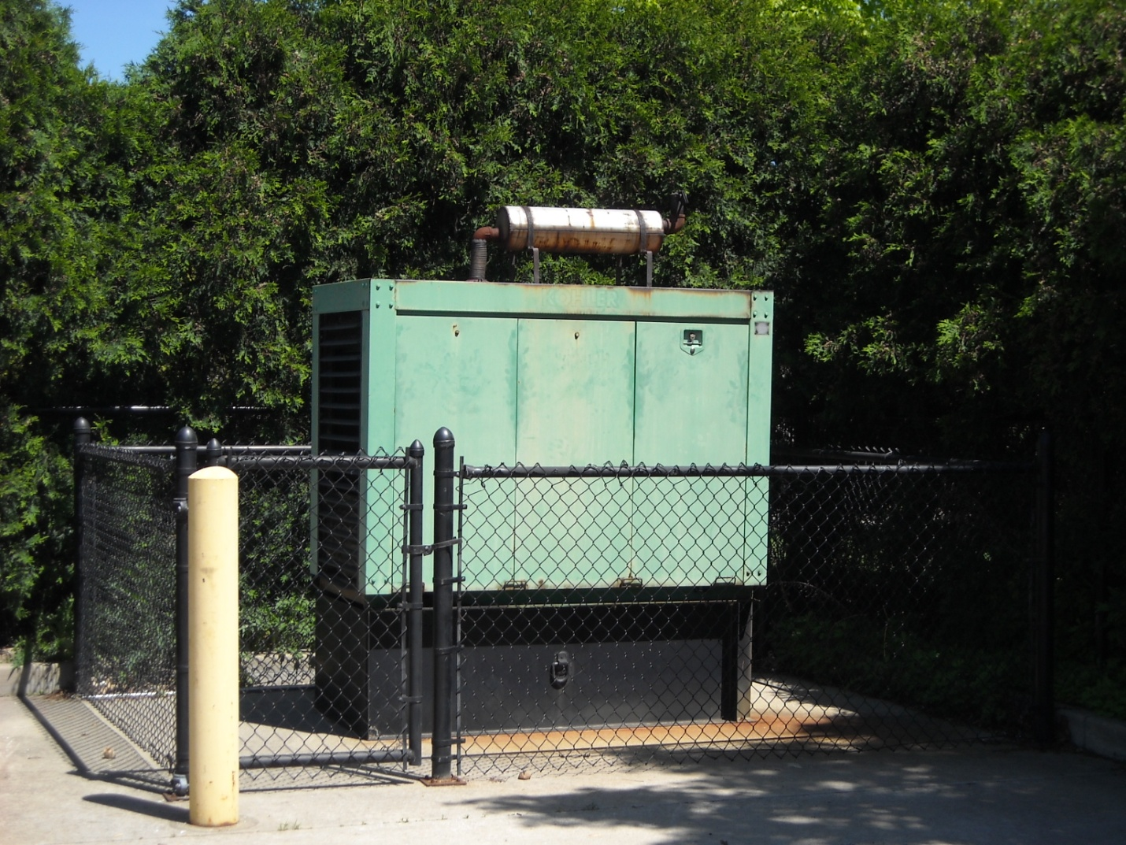

Emergency Generator (Administration Building)

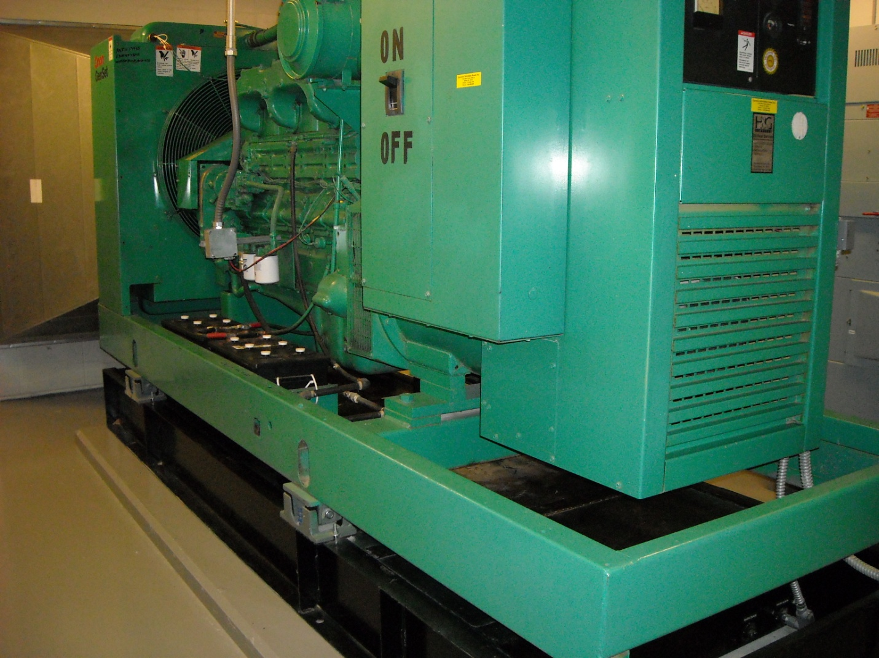

Emergency Generator (Student Activities Center)

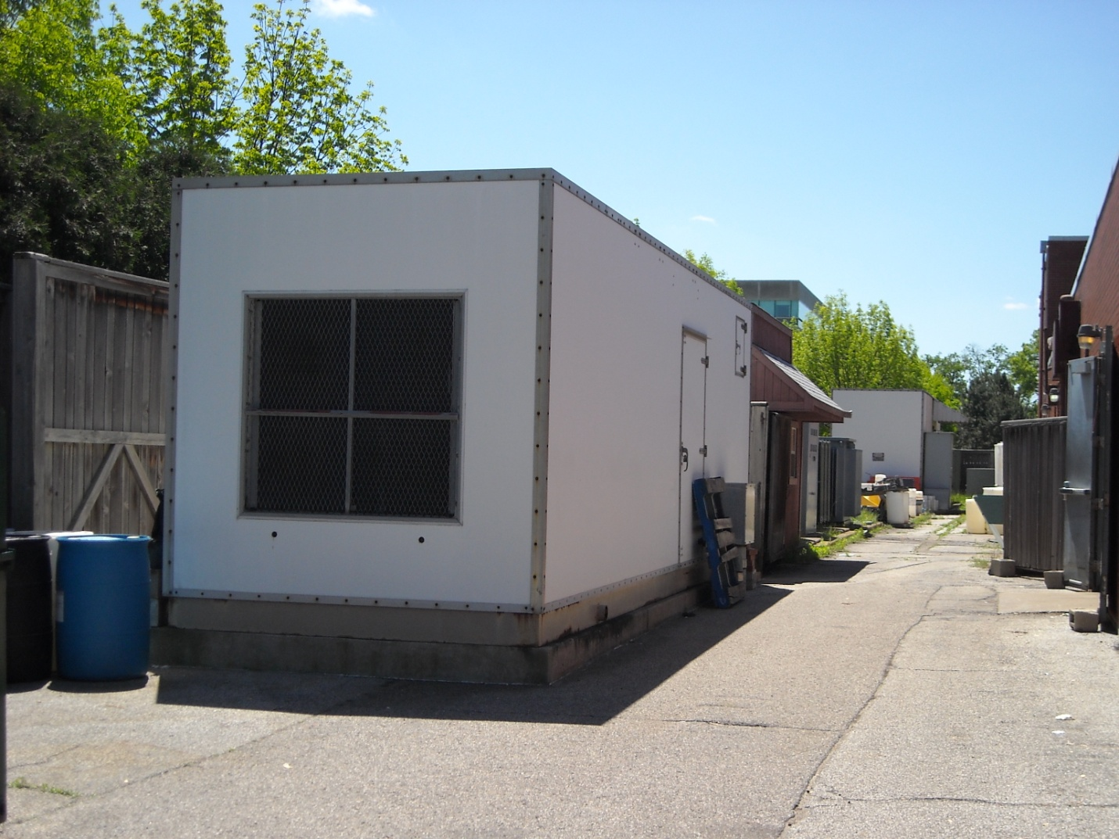

Emergency generator (Education & Arts Building smaller generator)

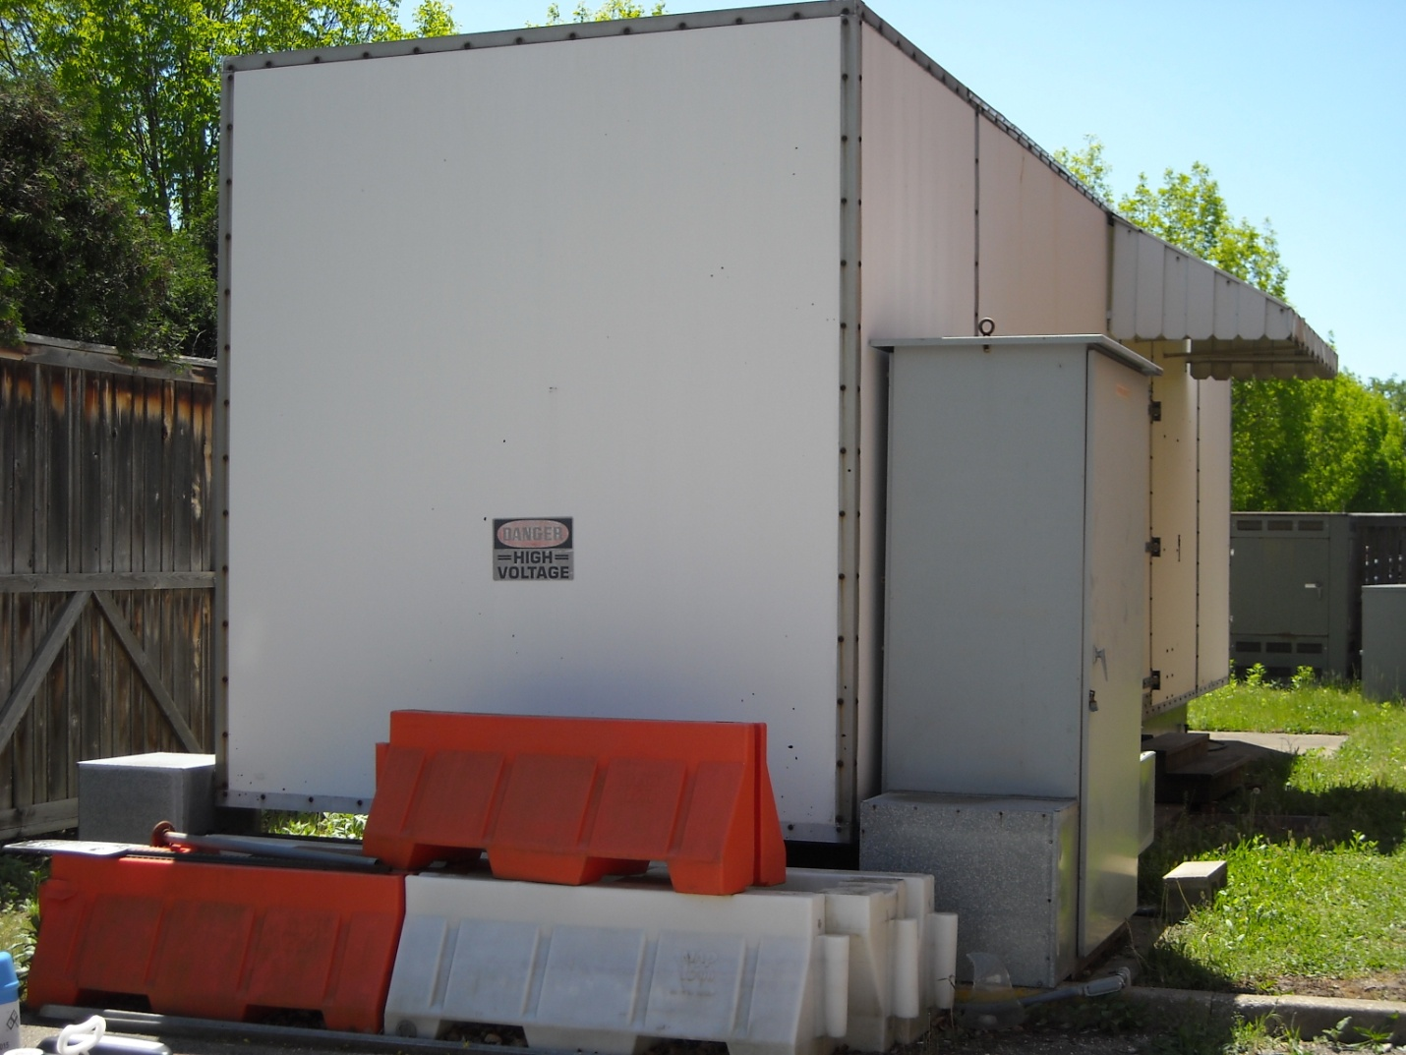

Emergency Generator (Education & Arts Building larger generator)

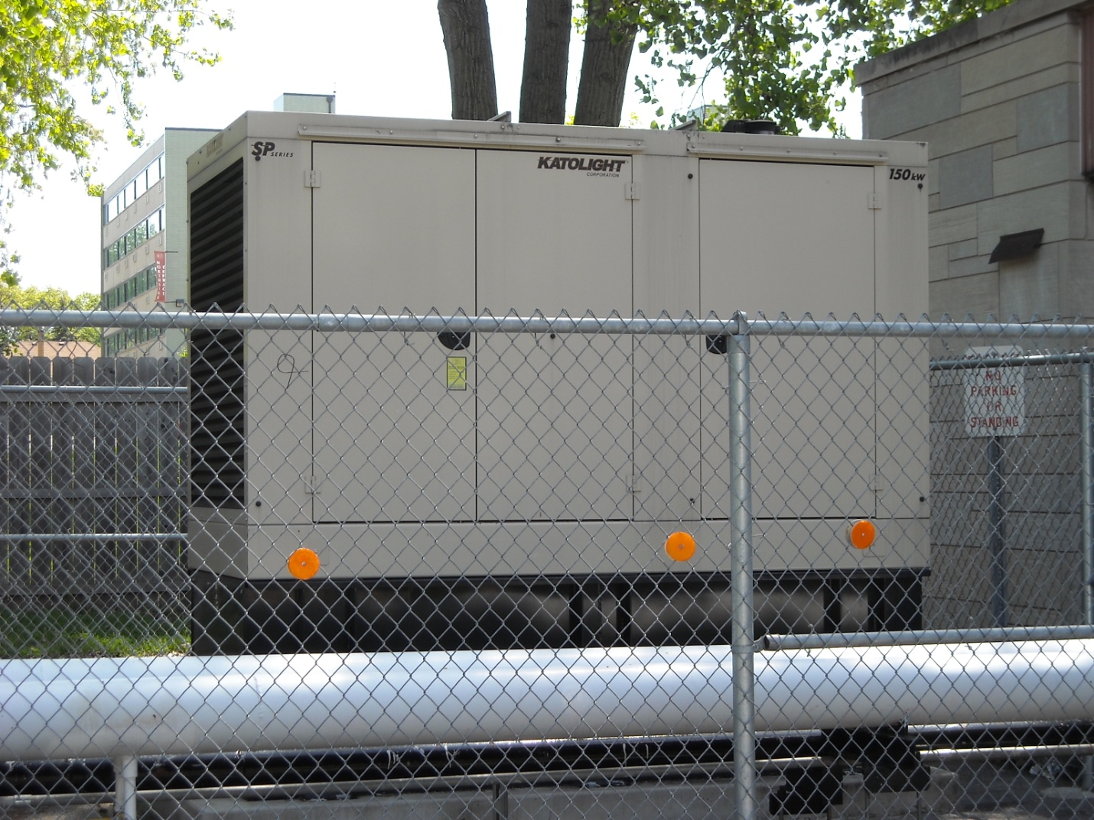

Emergency generator (Northside Hall)

Appendix 14 Storage Tank Photos

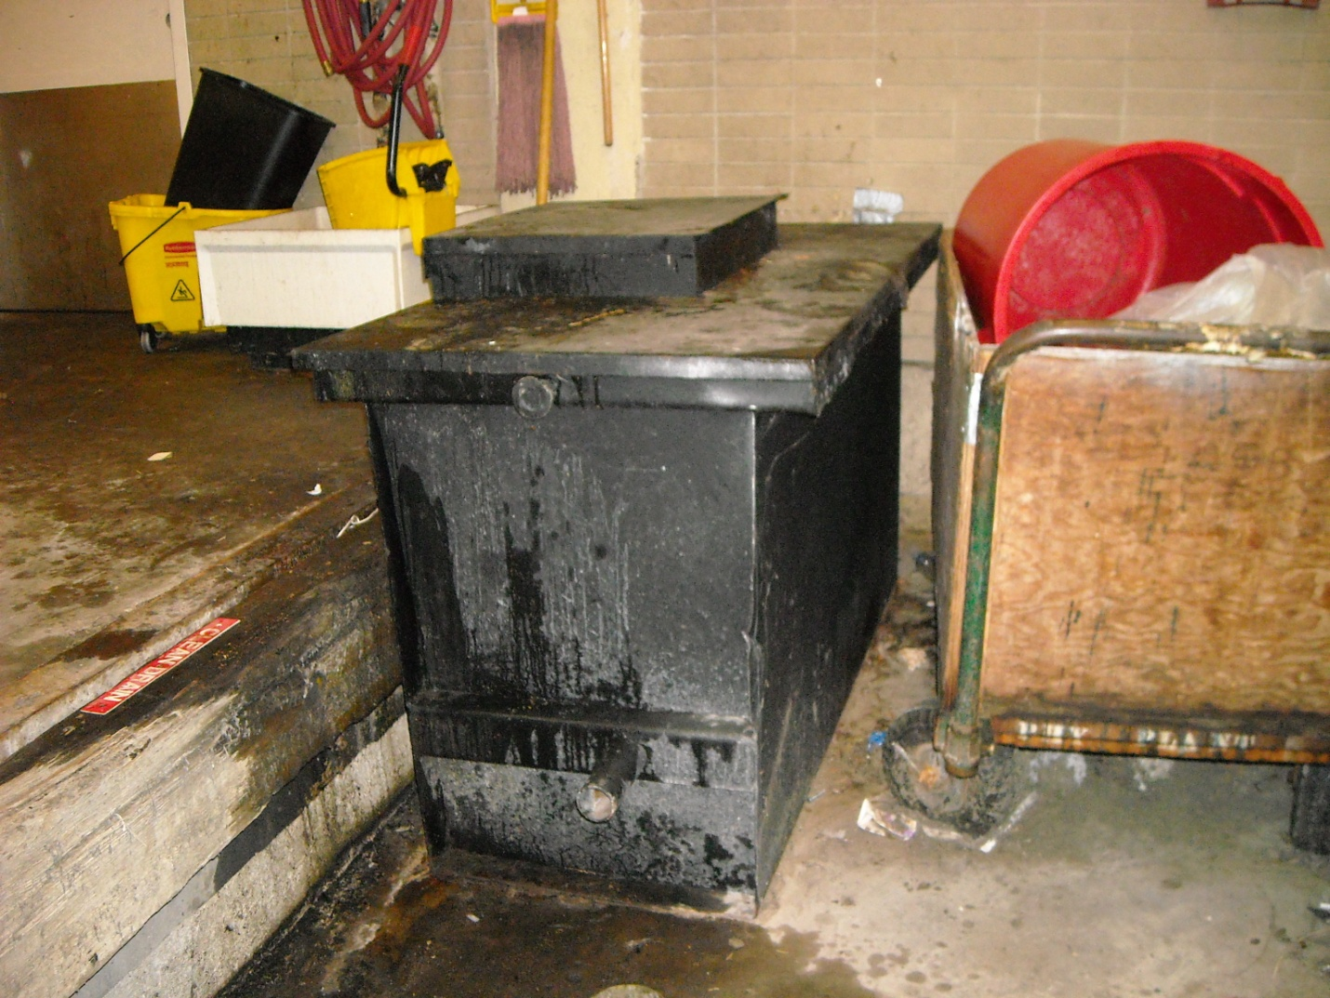

Cooking Oil Dumpster (Administration Building dock)

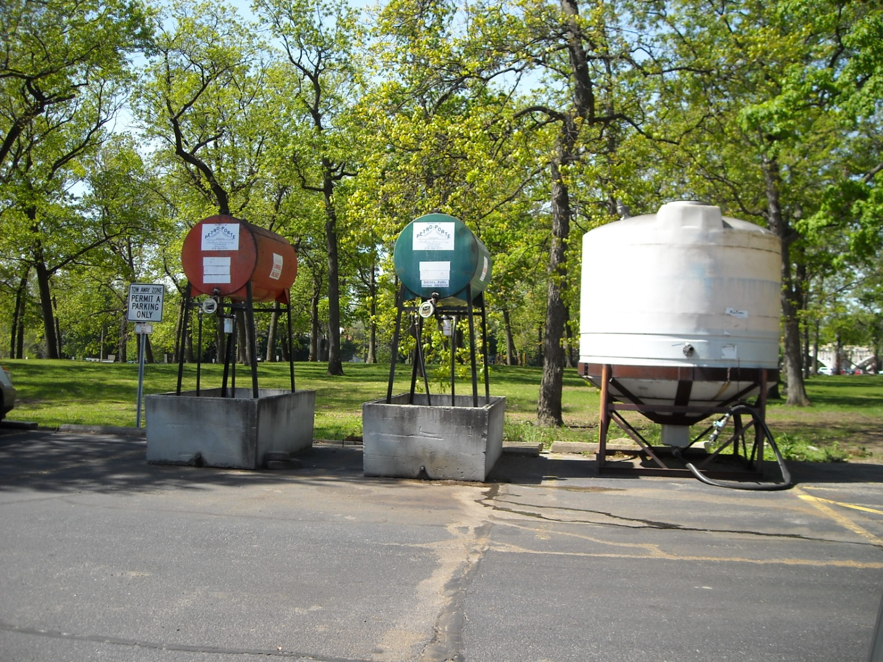

Gasoline and diesel tank (West of Purdue Technology Building)

Appendix 15 Topographic Map of IUSB

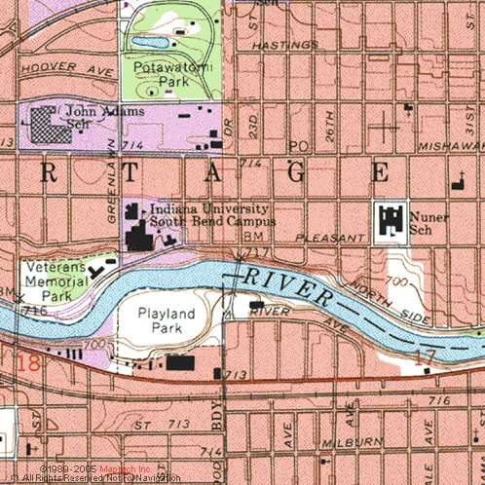
Appendix 16 IUSB Campus

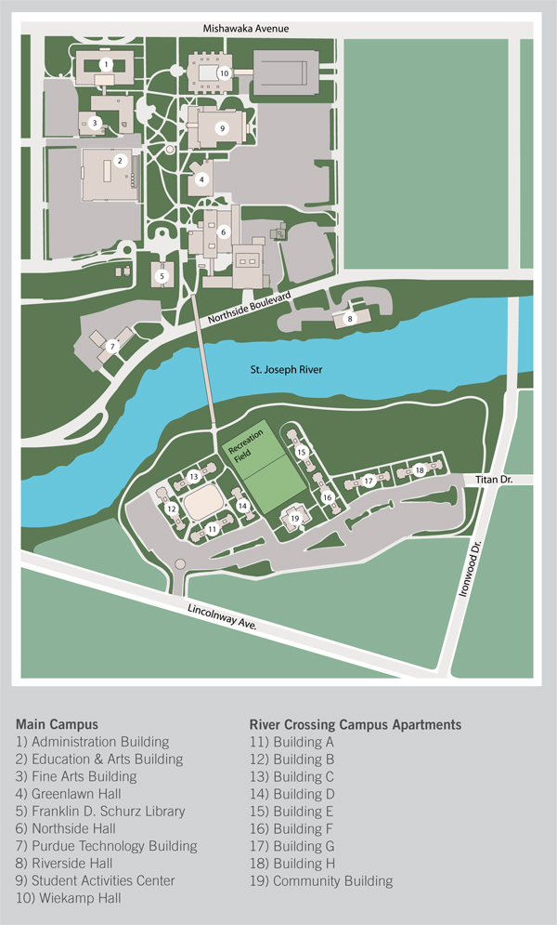

Appendix 17 Discharge Prevention Designee

SPCC Discharge Prevention Designee

The Environmental Health and Safety Department (EHS) will conduct initial Spill Prevention, Control, and Countermeasure (SPCC) training for employees of Indiana University. The initial training is required for all employees that use petroleum (gasoline, diesel, used oil, hydraulic fluid, etc…) in the performance of their regular duties.

In addition to the initial training requirement, discharge prevention briefings are required at least once a year. Discharge includes, but is not limited to, any spilling, leaking, pumping, pouring, emitting, emptying, or dumping of oil. The annual briefing will be conducted and recorded by a supervisor from each department familiar with its day to day operations. The supervisor in charge of the annual briefing will be identified as the designee accountable for discharge prevention. This requirement is defined below.

40 CFR 112.7
(2) Designate a person at each applicable facility who is accountable for discharge prevention and who reports to facility management.
(3) Schedule and conduct discharge prevention briefings for your
oil-handling personnel at least once a year to assure adequate understanding of the SPCC Plan for that facility.

Department:___________________________________________________

Discharge Prevention Designee:

Name:____________________________________________

Title:_____________________________________________

Phone number:_____________________________________

Email:____________________________________________

Date:__________________

Appendix 18 Discharge Prevention Briefing

Discharge Prevention Briefing

Location:_____________________________________________________
Date of Briefing:_______________________________________________

Briefing Conducted By:__________________________________________

The following items were discussed at the briefing:

(Check items discussed)

____ SPCC Plan
____ Applicable pollution control laws, rules and regulations
____ Spill events or failures at this or other facilities
____ Operation and maintenance of equipment to prevent spills
____ Spill operating procedures
____ Other __________________________________________________

Personnel in attendance: Print & Sign

1.________________________________________________________________________

2.________________________________________________________________________

3.________________________________________________________________________

4.________________________________________________________________________

5.________________________________________________________________________

6.________________________________________________________________________

7.________________________________________________________________________

8.________________________________________________________________________

9.________________________________________________________________________

10._______________________________________________________________________

11._______________________________________________________________________

12._______________________________________________________________________

The Discharge Prevention Briefing form should be kept with your SPCC Plan for 3 years.

Appendix 19 SPCC Audit Checklist

SPCC Audit Checklist-Partial

Date:

Auditor:

Tank Type: Generator___; Elevator___; Transformer___; Other AST____; UST___; Drums___

Location and room # if available:

40 CFR 112.7-General requirements

- Secondary containment:
Is the secondary containment 100% of the largest tank ( YES NO NA )
or 100% of the largest tank and 6” of freeboard if outside? ( YES NO NA )
Containment is free of cracks and openings and is impervious? ( YES NO NA )
Note: Oil in use such as hydraulic fluid in elevators and oil in transformers do not need secondary containment.
Additional Comments:

- Inspections, tests and records:
Are inspections and tests performed (including those outlined in Steel Tank Institute’s STI SP001-00) and records of said inspections and tests kept on file for three years?
( YES NO NA )
Were copies of said records sent to UOEHSM within 7 days of inspections and tests? ( YES NO NA )
Also see #6 below.
Additional Comments:

- Personnel, training and discharge prevention procedures:
Is there a designee accountable for discharge prevention? ( YES NO NA )
Are prevention briefings/trainings held at least annually? ( YES NO NA )
Are they documented? ( YES NO NA )
Has training been performed in the following areas:
Operation and maintenance of equipment to prevent discharges? ( YES NO NA ) Discharge procedural protocols? ( YES NO NA )
General facility operations? ( YES NO NA )
Contents of the SPCC plan and applicable rules and regulations? ( YES NO NA )
This training includes tank integrity testing and tank and line inspections, overfill prevention and spill response.
Additional Comments:

- Security:
Is access by the public is prevented? ( YES NO NA )
Additional Comments:

40 CFR 112.8-Requirements for on-shore facilities

- Drainage from containment:
Is there a Standard Operation Procedure (SOP) in place for the periodic drainage of precipitation from outdoor containments? ( YES NO NA )
Are records kept of all drainage? ( YES NO NA )
Is there spill absorbent material available near by along with appropriate oil booms and pads to deal with any oil leakage into the containment before drainage? ( YES NO NA )
Additional Comments:

- Integrity Testing:
Are each above ground storage tank (AST) tested for integrity on a regular basis?
This involves monthly visual inspection and a certified inspection including non-destructive shell tightness testing (hydrostatic, radiographic, ultrasonic or acoustic emissions) every 10 years. ( YES NO NA )
Are each AST tested for integrity when material repairs are made according to STI SP001-00? ( YES NO NA )
Note: STI SP001-00 covers the tank and supports only. Regular inspections of all above ground valves, piping and appurtenances are also mandatory.
Are leak and integrity testing performed regularly on valves and pipes not secondarily contained? ( YES NO NA )
Is the integrity of the secondary containment tested regularly? ( YES NO NA )
Additional Comments:

- Good Engineering Practices:
Are all implemented overfill preventative devices tested regularly and documented?
Example: High liquid level alarms, auto shutoff valves, fuel level gauges with a SOP describing proper filling techniques, ect.
( YES NO NA )
Additional Comments:

- Address all releases promptly:
Were incidents addressed and reported in a timely fashion? ( YES NO NA )
Additional Comments:

List all deficiencies under the proper heading above and note any additional comments or observations below.

